Used Car Price Prediction using Simple Linear Regression

Table of Contents
Section | Page No.
1. Project Summary | 1
2. Project Workflow | 1
3. Code Explanation | 2
3.1 Import Libraries | 2
3.2 Load Dataset | 2
3.3 Data Cleaning | 2
3.4 Feature Selection | 2
3.5 Train-Test Split | 3
3.6 Model Training | 3
3.7 Prediction | 3
3.8 Model Evaluation | 3
3.9 Save Model | 3
4. Graph Explanation | 4
5. Errors Faced and Solutions | 4
6. Results | 5
7. Conclusion | 5

1. Project Summary

Objective
Predict the selling price of a used car using the manufacturing year (yr_mfr) with Simple Linear Regression.

Dataset
- Rows: ~7400
- Columns: 29
- Target: sale_price
- Feature Used: yr_mfr

Tools
- Python
- Pandas
- NumPy
- Matplotlib
- Scikit-learn
- Streamlit

2. Workflow
CSV File
│
▼
Load Dataset
│
▼
Clean Data
│
▼
Select Feature
│
▼
Train-Test Split
│
▼
Train SLR Model
│
▼
Prediction
│
▼
Evaluation
│
▼
Save Model
│
▼
Streamlit App

3. Code Explanation

Load Dataset
dataset = pd.read_csv(filepath)
Explanation
- pd.read_csv() → Reads the CSV file.
- dataset → Stores the data.

Remove Missing Values
dataset = dataset.dropna(
subset=["yr_mfr","sale_price"]
)
Explanation
- dropna() → Removes rows with missing values.
- subset → Checks only selected columns.
- Clean data improves model accuracy.

Remove Duplicate Rows
dataset = dataset.drop_duplicates()
Explanation
- Removes duplicate records.
- Prevents repeated data from affecting training.

Select Features
X = dataset[["yr_mfr"]]

y = dataset["sale_price"]
Explanation
- X → Input feature.
- y → Target value.

Split Dataset
train_test_split(
X,
y,
test_size=0.2,
random_state=0
)
Explanation
- 80% → Training
- 20% → Testing
- random_state → Produces the same split every run.

Train Model
regressor.fit(X_train,y_train)
Explanation
- Trains the model.
- Learns the relationship between year and selling price.

Prediction
y_pred = regressor.predict(X_test)
Explanation
- Predicts selling prices for test data.

Save Model
pickle.dump(regressor,file)
Explanation
- Saves the trained model.
- No need to train again.

4. Graph Explanation

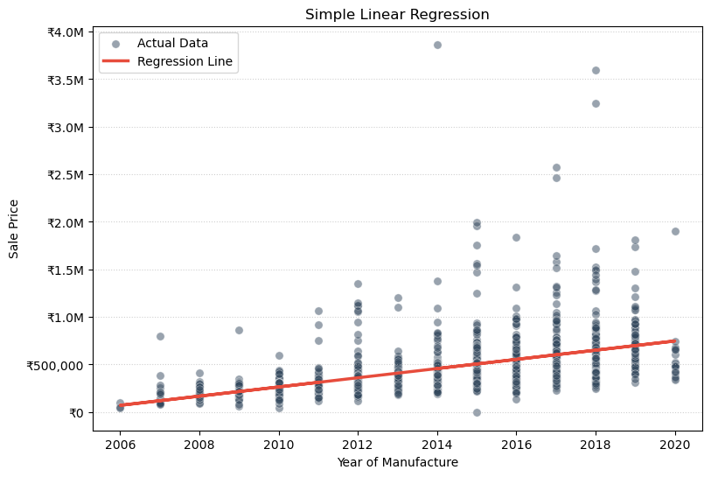

What does the graph show?
- Blue dots represent actual car prices.
- Red line represents the regression model.
- Upward line shows newer cars generally have higher prices.

Observation
- Positive relationship between year and price.
- Some points are away from the line because price also depends on mileage, brand, and fuel type.

5. Errors Faced and Solutions
Error | Cause | Solution
FileNotFoundError | Wrong dataset path | Corrected the file path.
Missing values | Some records had empty values | Used dropna().
Duplicate rows | Dataset contained repeated records | Used drop_duplicates().
Shape mismatch | Incorrect feature selection | Passed X as a DataFrame using dataset[['yr_mfr']].
ModuleNotFoundError | Required package was missing | Installed the package using pip install.
Pickle file not loading | Incorrect file path | Verified the .pkl file location.
Streamlit app not running | Wrong command or environment | Ran streamlit run app.py in the correct folder.

6. Results
Metric | Value
MAE | ₹149,147
RMSE | ₹267,311
R² Score | 0.24

7. Conclusion
- Built a Simple Linear Regression model.
- Predicted used car prices using manufacturing year.
- Evaluated the model using MAE, RMSE, and R² Score.
- Deployed the model using Streamlit.
- The model works well as a basic price prediction system.

